
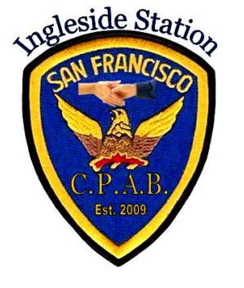

This Voluntary program is being sponsored by SFPD, Ingleside Police Station and (CPAB) Community Police Advisory Board. If you wish to participate, please fill in the information on this form and send back to us via the Bike Registration page on inglesidepolicestation.com. You will receive a registration sticker in the Mail.
You can also walk into Ingleside Station and fill out the form there to get your sticker. Please fill out all required fields, except the ones marked with the asterisk *. If you have a current photo of your bicycle please attach it.

This registration program is not intended to stop bicycle theft, but as a deterrent. With the registration it makes it easier to track stolen bicycles by serial numbers and other information when they are recovered. This also speeds up the process of returning bicycles to the rightful owners.

SF,CA

